Title

Our Peace Tree – Growing Kindness Together
Year Group: (4-5 years)

Learning focus/ intentional teaching
This learning experience helps children to learn about social sustainability through this Peace book using the principles of kindness, inclusion, empathy and belonging. The teacher deliberately teaches children to identify how their actions in the classroom can have a positive impact on the classroom community. The educator exemplifies respectful communication, supports and stretches children's thinking with open-ended questions and invites continuous shared thinking around the need for peaceful behaviours to ensure everyone feels safe and included.

How children’s agency, curiosity, creativity and critical thinking are fostered

Children are engaging in activities that encourage them to share their own thoughts on what peace is and select one ‘kind action' they can take, and are encouraged to make decisions and take action. They have discussions about real-life experiences of kindness and inclusion to encourage their curiosity. Children decorate a paper leaf with a drawing or written message that is a peaceful action they have chosen to take, promoting creativity. As children consider various social scenarios, reflect on the emotions of others and propose respectful solutions to problems and ensure everyone is included in play, their critical thinking skills are enhanced.

List required resources and added photos:
The Peace Book by Todd Parr, large paper tree, green paper leaves, markers, crayons, pencils, glue/Blu Tack, chart paper and photographs of children showing kind behaviours.
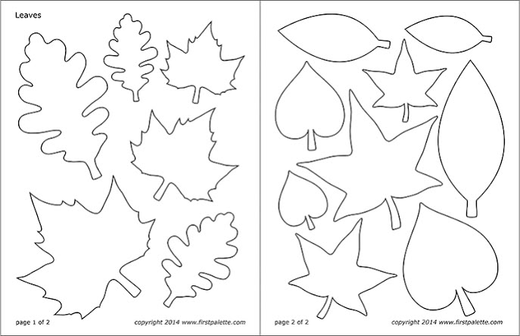
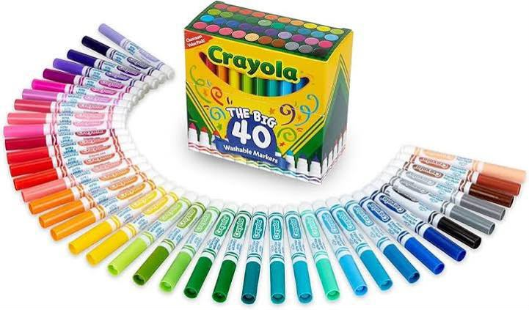

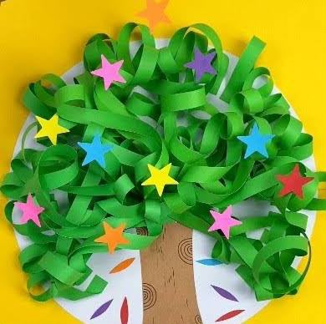

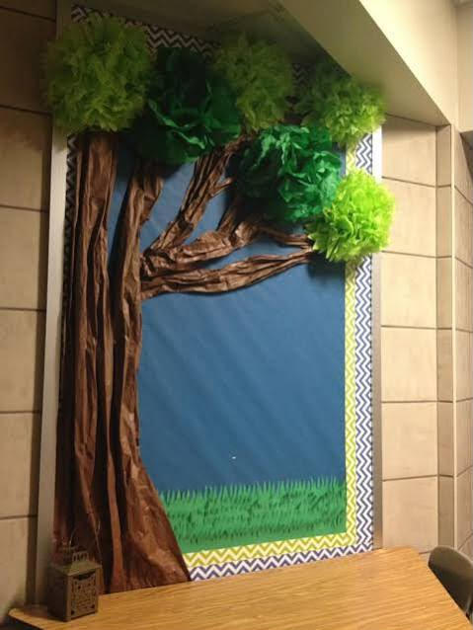

Implementation process/steps
The educator starts by reading The Peace Book and asking open-ended questions like, “What does peace look like in our classroom?” and, “How can we make everyone feel included?” Children's ideas are jotted down before they decorate one of the types of actions they can practise on a paper leaf. These leaves are added to the classroom Peace Tree and forms a common display to celebrate inclusion and kindness. Role play, story telling and cooperative games and frequent reflection on peaceful behaviour in class are used to extend the learning.
Introductory Phase: how would you introduce the selected sustainability picture book?
What are the pedagogical practices you will embed throughout the activity, including: intentional teaching, modelling, scaffolding, sustained shared thinking, responsive interactions, provocations, open-ended questioning etc.?
The educator gathers children in a circle and introduces The Peace Book by Todd Parr by showing the cover and asking, "What do you think peace means?" and "How can we make everyone feel welcome?" During the shared reading, the educator pauses to encourage discussion using open-ended questions and invites children to share their own experiences. Throughout the story, the educator embeds intentional teaching by modelling kindness and respectful language, scaffolding children's thinking, engaging in sustained shared thinking, responding to children's ideas through responsive interactions, and using the story as a provocation to explore inclusion, empathy and peaceful relationships.

Main Activity: from here you will be following the shared reading experience, and transition children into the main activity area where the sustainability concepts from the book will be extended through hands-on, play-based learning experiences.
Children decorate a paper leaf with one kind action they can do to create a peaceful classroom and attach it to the class Peace Tree. The educator extends learning through discussion, role-play and cooperative play.
Closing Phase: you will gather children to reflect on their learning experience and revisit the key sustainability concepts explored through the story and activity.
Children reflect on what they learned, discuss how kindness strengthens their community, and revisit the Peace Tree as a reminder to practise peaceful behaviours every day.

EYLF Learning Outcomes:
For example  Outcome 1: Children have a strong sense of identity  1.1. Children feel safe, secure and supported  1.4. Children learn to interact in relation to others with care, empathy and respect | Outcome  Outcome 1: Children have a strong sense of identity (1.1, 1.4).  Outcome 2: Children are linked to and involved in their world (2.1, 2.2, 2.3). Outcome 3: Children have a good sense of wellbeing (3.1).  Outcome 5 (5.1, 5.2): Children are effective communicators.

