Title
Recycling Detective – Caring for Our Earth
Year Group: (4–5 years)

Learning focus/ intentional teaching

Through this learning experience children will be introduced to ecological sustainability using The Earth Book by Todd Parr, focussing on recycling, conserving resources and reducing waste. The teacher purposefully teaches the children that everyday activities can make a difference to the environment. The educator demonstrates sustainable practices, uses questions to scaffold children's thinking, allows children to problem solve together and supports responsible decision making while children are exploring through play.

How children’s agency, curiosity, creativity and critical thinking are fostered

Children show ‘agency’ when they choose to sort the recyclables by themselves, and they can suggest sustainable actions which they can practise daily. They are stimulated to be curious by exploring various materials and explaining their uses. Children are learning to think critically as they compare, justify, and reflect on recycling and the benefits to the Earth. The children are encouraged to be creative by drawing or writing a promise to do something to protect the environment on the chart "Earth Helpers Promise.

List required resources and added photos:

Recycling bins (Paper, Plastic and General Waste), Cardboard boxes, Newspapers and magazines, Paper towel rolls, Plastic bottles, Yoghurt containers, Food packaging, Chart paper, Markers and pencils are marked on the Earth Book.
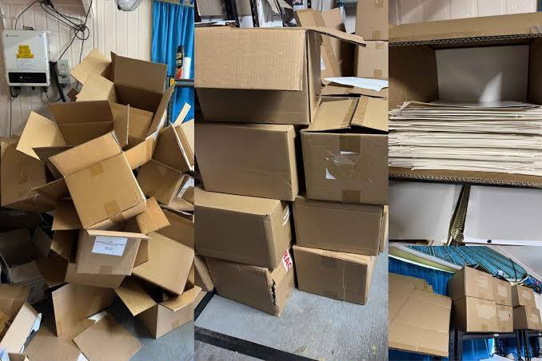
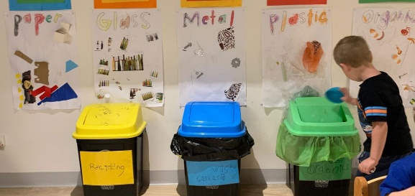

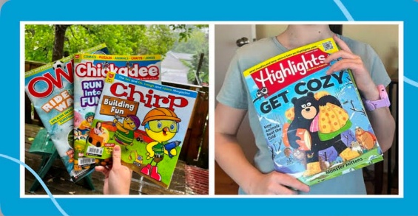
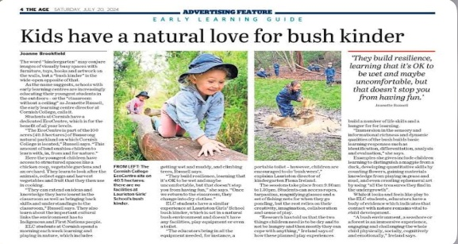

Implementation process/steps
The educator presents The Earth Book using a shared reading approach that hosts a discussion using open-ended questions, such as, "What can we do to help the Earth?" "Why is recycling important? The educator engages children in understanding environmental responsibility through intentional teaching, modelling, scaffolding, sustained shared thinking and responsive interactions. Children then explore and categorize common recyclable items into the correct bins and discuss their decisions and whether they can be reused or recycled. This experience ends with the children making an "Earth Helpers Promise" chart on which each child promises to take a sustainable action. It is posted in the classroom to remind them of the need to reflect and act responsibly for the environment.
Introductory Phase: how would you introduce the selected sustainability picture book?
What are the pedagogical practices you will embed throughout the activity, including: intentional teaching, modelling, scaffolding, sustained shared thinking, responsive interactions, provocations, open-ended questioning etc.?
The educator introduces The Earth Book by Todd Parr through a shared reading, encouraging children to predict the story and discuss ways to care for the Earth. Intentional teaching, modelling sustainable behaviours, scaffolding, sustained shared thinking, responsive interactions and open-ended questions support children's understanding of recycling and conservation.
Main Activity: from here you will be following the shared reading experience, and transition children into the main activity area where the sustainability concepts from the book will be extended through hands-on, play-based learning experiences.
Children become "Recycling Detectives," investigating everyday items and sorting them into labelled recycling bins while explaining their choices and discussing how recycling helps the environment.
Closing Phase: you will gather children to reflect on their learning experience and revisit the key sustainability concepts explored through the story and activity.
Children reflect on what they learned and create an "Earth Helpers Promise" by sharing one sustainable action they will practise every day.

EYLF Learning Outcomes:
For example  Outcome 1: Children have a strong sense of identity  1.1. Children feel safe, secure and supported  1.4. Children learn to interact in relation to others with care, empathy and respect | Outcome  Outcome 2: Children are connected with and contribute to their world (2.1, 2.2, 2.4).  Outcome 4 Children are confident and involved learners (4.1, 4.2, 4.4). Outcome 5: Children are effective communicators (5.1, 5.2).

